IT Staff Augmentation Contracts (ITSAC) Portal
Vendor User Guide
Version: 3.00
Chief Procurement Office (CPO)
Effective Date: 10/01/2020

Service Solicitation Request (SSR) – Vendor
Vendors will access the ITSAC Vendor Portal to review posted Solicitation Requests from Customers and to respond to open Solicitations by submitting candidates to Request for Resumes or Statement of Work (SOW) proposals, depending on the type of solicitation. Once the deadline date has passed, the Customer will review vendor responses, then reach out to potential Vendors and award the Solicitation accordingly.
Note – Customers may choose to post solicitations outside of the ITSAC Portal via email.

Request for Resumes Solicitation – Submitting Candidates
This section will walk you through accessing the ITSAC Vendor Portal and posting candidates for consideration.

Open a web browser and navigate to the DIR website at https://dir.texas.gov/
Note: The ITSAC Portal is optimized for Google Chrome or Mozilla Firefox.

Click on the "Sign into My DIR" button.
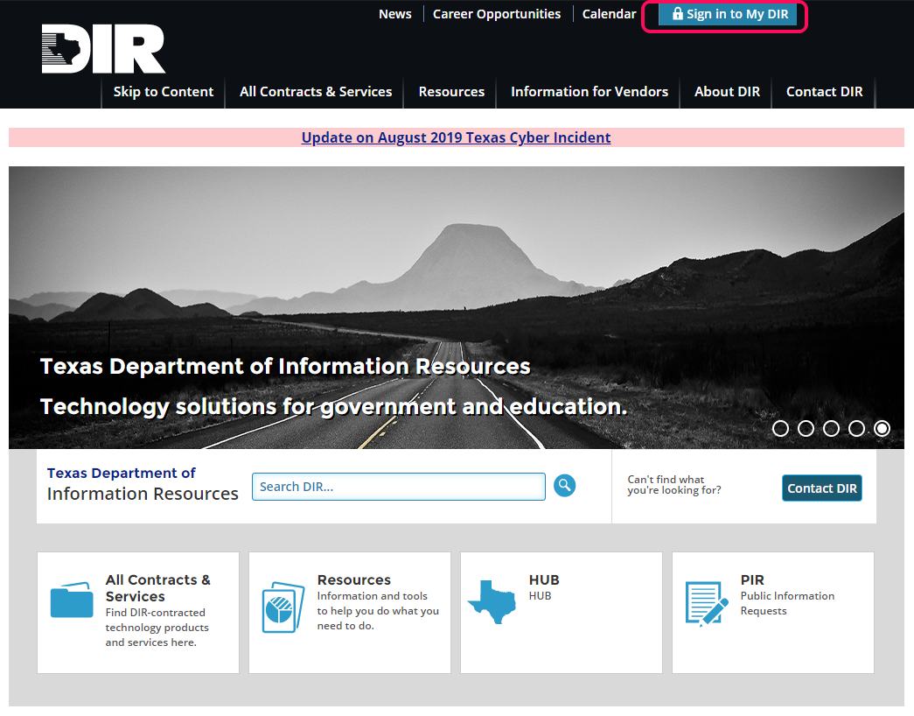

Navigate to the DIR ITSAC Vendor Portal link.
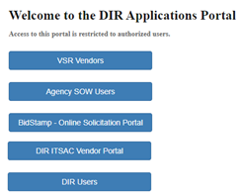

Log into the ITSAC Vendor Portal with your credentials.
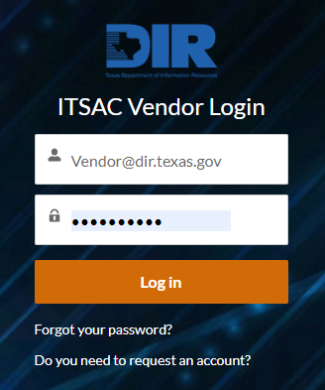
Note: Request a temporary password by clicking on the Forgot your password? link. If you do not have an account, please send a request to DIRStaffAugmentation@dir.texas.gov.
Currently, each Vendor is issued one user account.

Once logged in, you will be navigated to the Home Page. The Home Page contains all Solicitations that have been posted to your (Vendor) company. The landing page has been filtered so that, by default, only open solicitations are displayed. To view previous/closed solicitations, click the “View Closed Solicitations” link

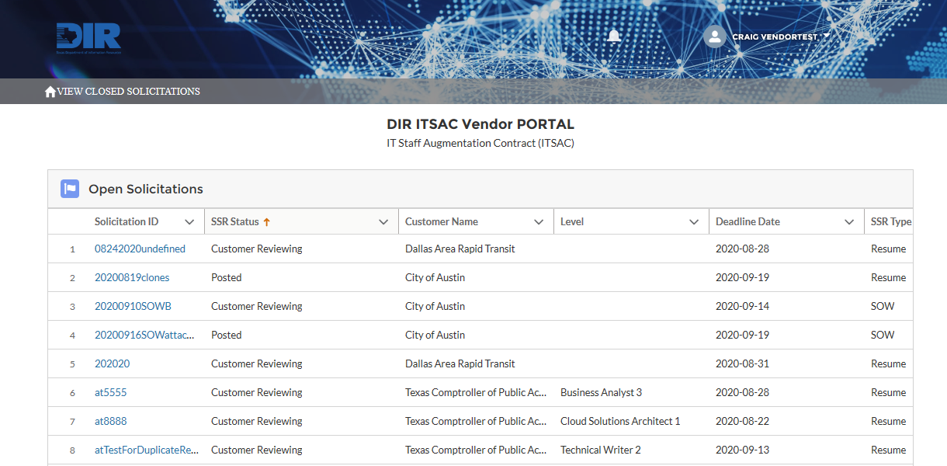
Below are the columns that are listed on the Home Page (click on the Column header to sort the column ascending or descending).
Column | Description
Solicitation ID | Unique ID set by the Customer, hyperlink to review Solicitation details and add Candidates
SSR Status | Status of the Solicitation Request  Posted – Solicitations that have been posted and sent to vendors for review. Vendors can review and submit candidates up until the Deadline Date.  Reviewing Resumes – Solicitations that have been posted and the Deadline Date has passed. The Customer then reviews the candidates posted from all vendors before making its selection.
Customer Name | Name of Customer (Agency) that posted the Solicitation
Level | Title and Level of the position requested by the Customer  - If you see a blank in this column, it is an indication that the solicitation is for an undefined title/level.
Deadline Date | Deadline Date (at 5:00 PM Central) that vendors can submit candidates for consideration.
SSR Type | Indicates the solicitation (record) is for a Request for Resume(s) or a Statement of Work (SOW)/Proposal.
# of Resumes Allowed | # of Resumes Allowed that can be submitted by each vendor
Candidates Submitted | # of Candidates submitted by the Vendor
SOW Responses Submitted | # of SOWs/Proposals submitted by the Vendor
Posted Date | Date that Customer posted the Solicitation

Click on the Solicitation link that has a status of ‘Posted’ to begin review.
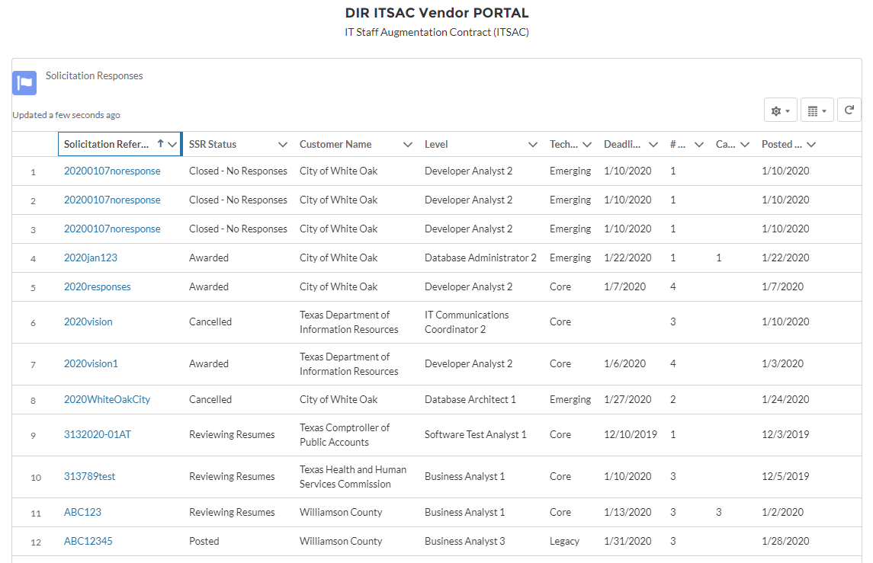
Note: Notifications of Soliications will be received via email (see below for example). Contact your Contract Manager to manage this process.
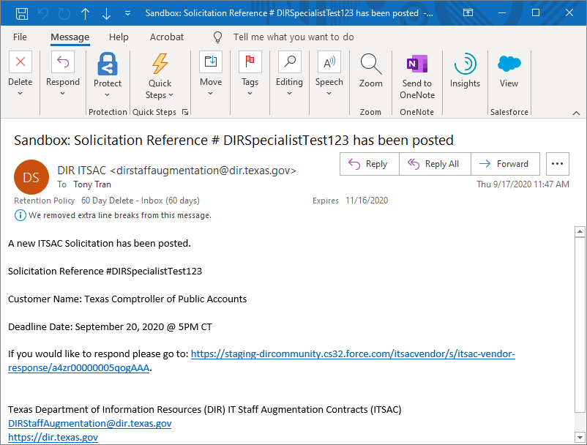

There are four tabs to review: Solicitation, Details, Download Forms, and Candidates.
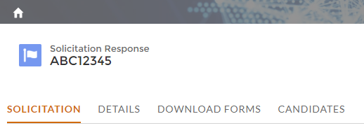

Solicitation – Contains the Solicitation Document submitted by the Customer with the requirements for the position.
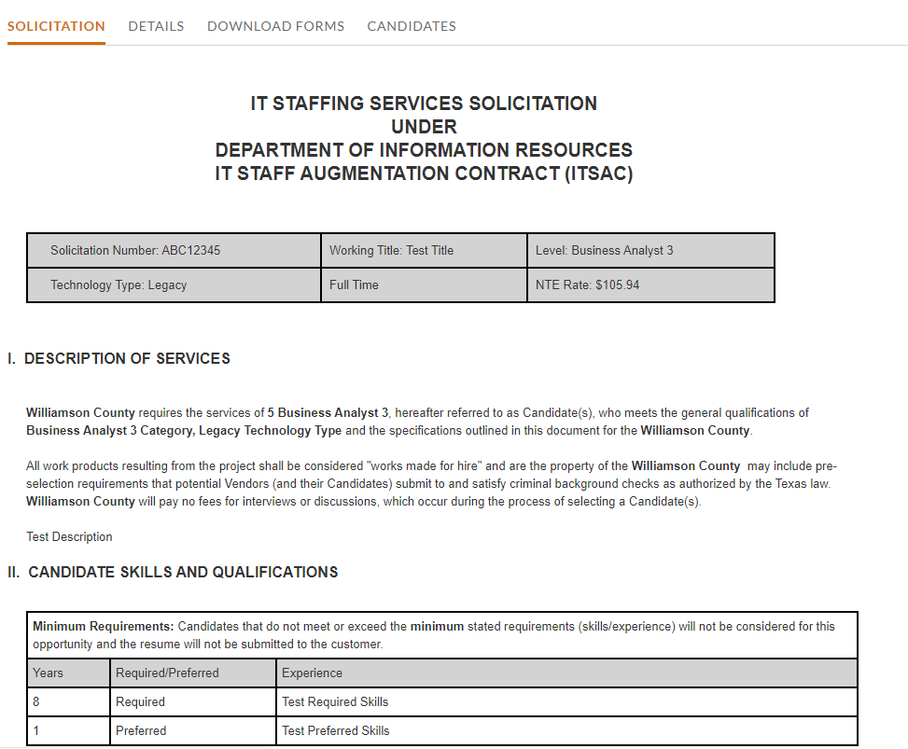

Details – Contains additional details of the Solicitation
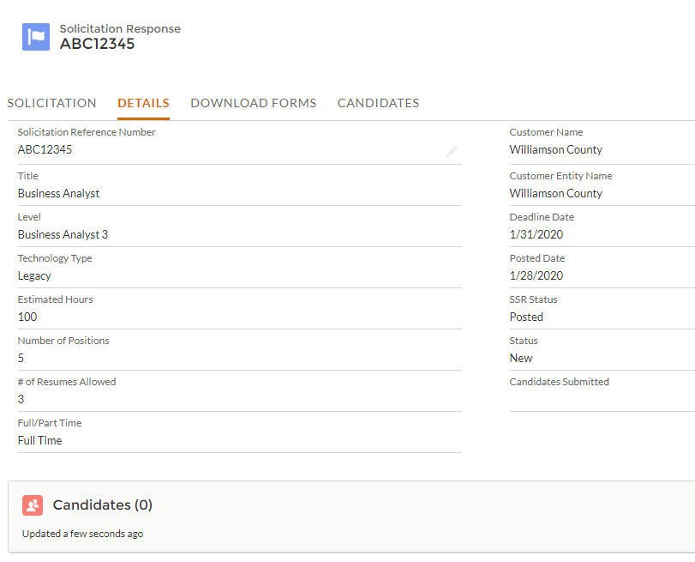
Note the Deadline Date and the # of Resumes allowed per Vendor.

Download Forms – Contains a download link with the packet that must be filled out by the Vendor for each candidate.
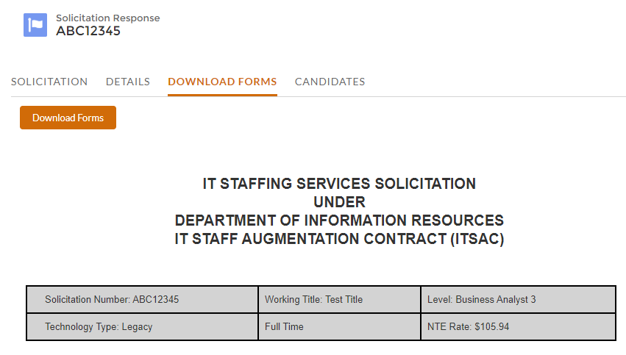

Candidates – Displays all candidates submitted by the Vendor.
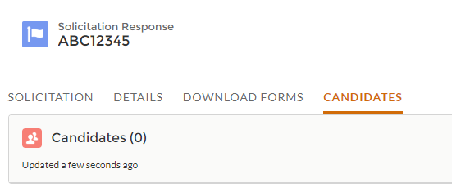

Add Candidate – Begin adding candidates by clicking the Add Candidate button.
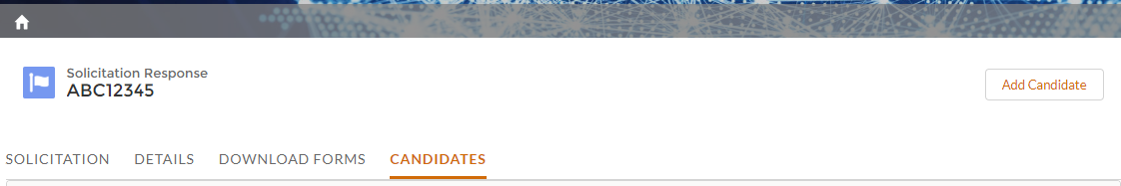
- Note – The “Add Candidate” button only appears while the solicitation is in a “Posted” status. Once the deadline for the solicitation has passed, this button will no longer appear and no additional candidates can be submitted for the solicitation.

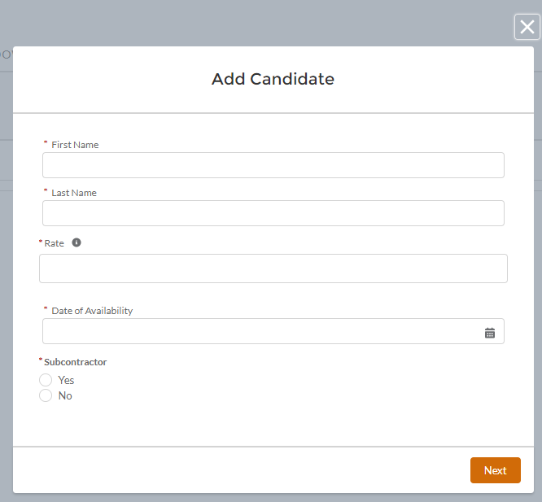
Enter in the candidate’s First Name, Last Name, Hourly Rate, the Date of Availability, and if the candidate will be hired through a Subcontractor.
(Click on the ‘i’ icon to view the max rate allowed)
Note – If the solicitation is for an Undefined Title or for a Specialist, there is no NTE rate. A message will appear:
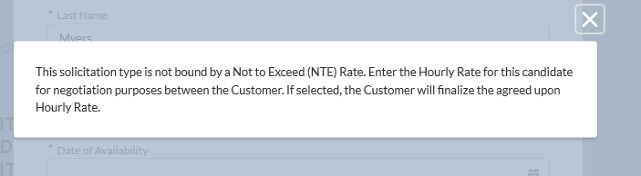
Sub-Contractor Information - If Sub-Contractor is selected, enter the Sub-Contracted Vendor Name, Sub-Contract Percentage, and HUB Type. Click Next once complete.

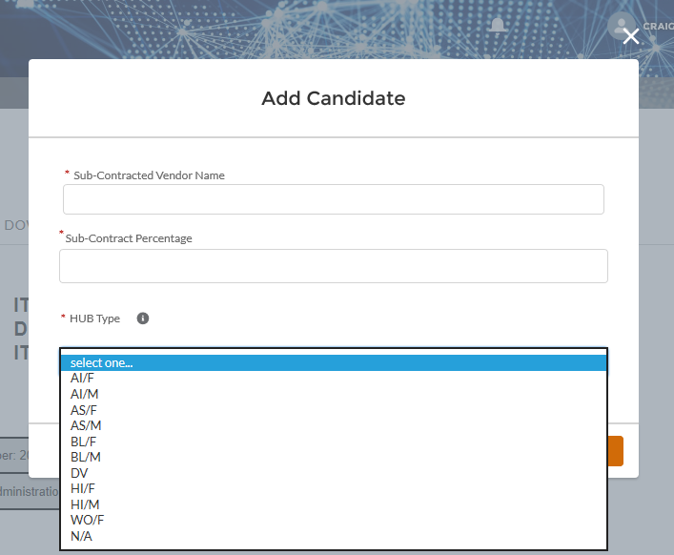
- Note – For a “Legend” defining what each Hub Type appreviation stands for, click the “I” icon.

Candidate Skills – Enter the number of years that the candidate has for each skill.
Note: Default the number of years to ‘1’ if skill is not measured by years (such as a requirement of a certificate).
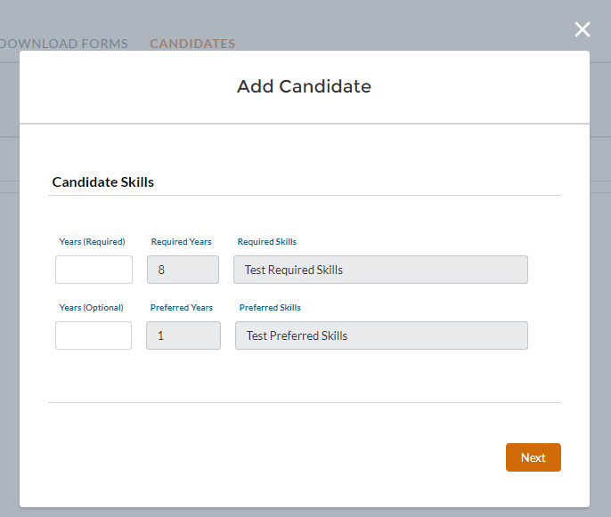
Note: Per contractual requirements, the candidate must meet the minimum required number of years based on the position Category, Title, and Level. If the candidate does not have the skill requested, enter 0.

Upload Candidate PDF – Upload the candidate’s completed PDF packet based on the instructions listed.
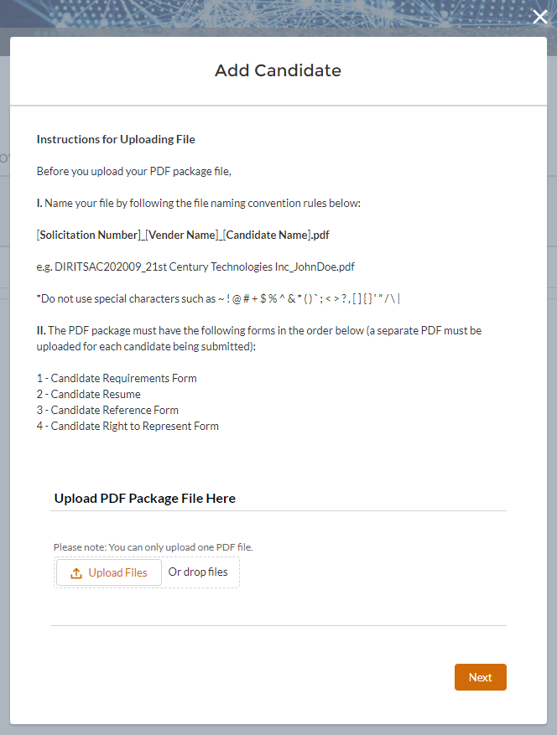
Note: Per contractual requirements and the Right to Represent form, if the candidate was submitted by multiple vendors for the same Solicitation, the candidate will be displayed to the customer as a potential duplicate , and vendors will be notified of the potential duplicate, but the customer will still have the option to review the candidate(s) and award.

Additional Comments – Add any comments related to the candidate for the Customer to consider.
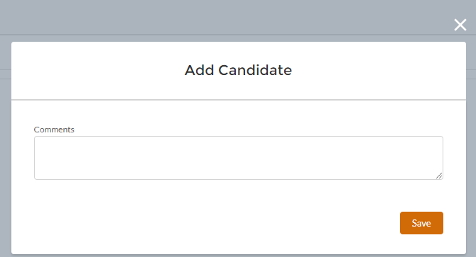
Click Save. The candidate will now appear in the list of Candidates.

Edit Candidate - Review the candidate by clicking on the Candidate ID.
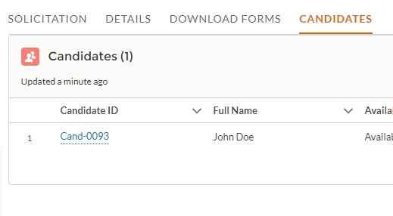
Candidate’s details will be displayed. Click on the Edit icon to update editable fields.
Note: Click on the Response or Candidate hyperlink to return to those screens.
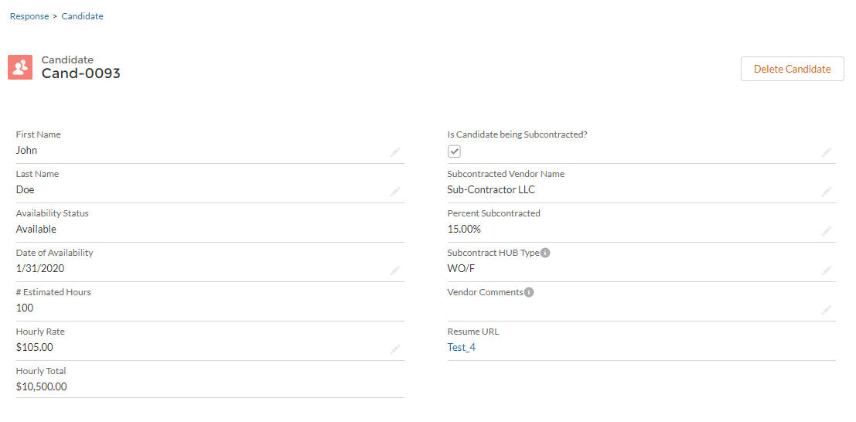
Click Save once complete.
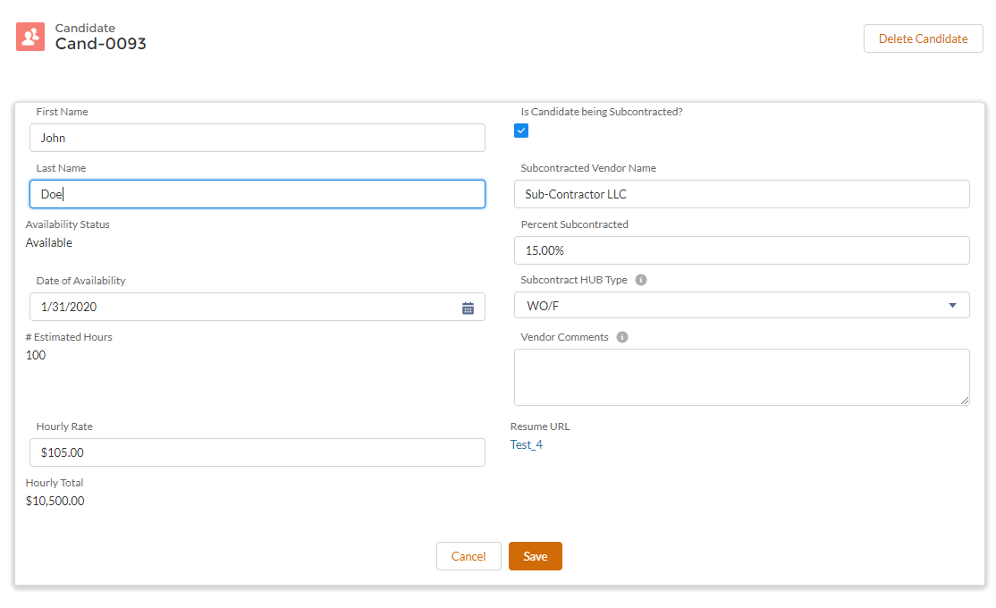

Delete Candidate – Candidates can be removed at any time before the deadline. Delete a candidate by clicking on the Delete button.
Note - Once the deadline has passed, candidates will be sent to the Customer and cannot be removed.
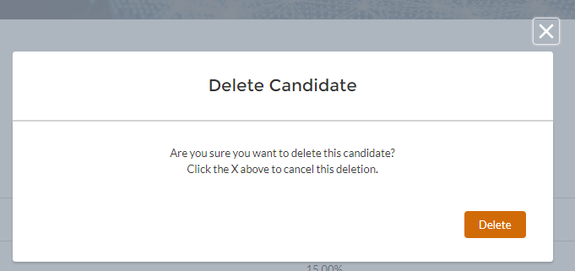

Click on the Home icon to return to the list of Solicitations. Verify that candidates have been added by reviewing the Candidates Submitted column.
Note: Candidates submitted can be removed or edited at any time prior to 5:00 PM Central on the Deadline Date. The Customer may amend the deadline date or cancel the Solicitation, which you will receive an email notification noting the Solicitation Status change.

Statement of Work (SOW) – Submitting Response
Customers will submit Solicitation Requests for SOWs for Vendors to review and submit SOW responses for consideration.

Notifications
When a SOW Solicitation is posted via the ITSAC Portal, all vendor contacts associated with the ITSAC Portal will receive an email.
Note – Contact your Contract Manager at DIR to set up accounts to receive notifications of ITSAC Solicitations.
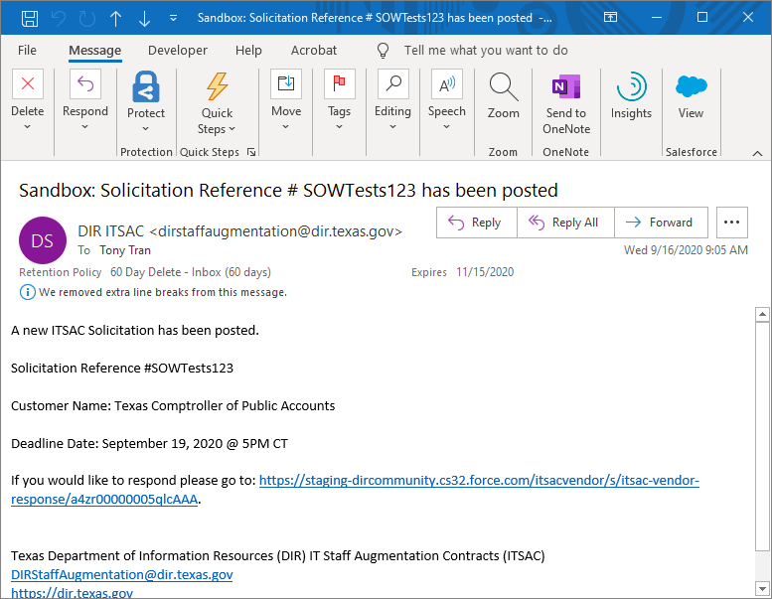

Accessing ITSAC Portal
Log into the ITSAC Vendor Portal by going to https://www.dir.texas.gov/ and clicking on Sign in to My DIR,
Once logged in, click on the VSR Vendors link.
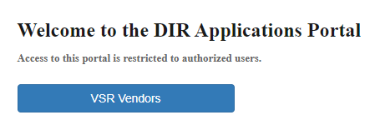

ITSAC Vendor Portal Home Screen
Once logged in, you will be navigated to the ITSAC Vendor Portal Home screen.
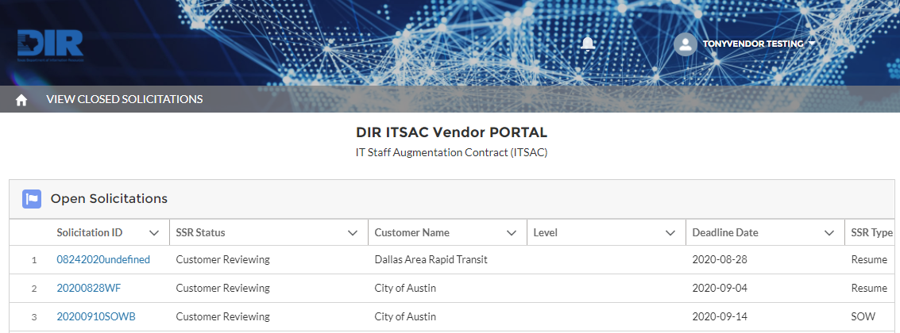 The following table contains all active solicitations with the following columns:
Column Header | Description
Solicitation ID | Customer defined reference ID. Click this link to access the solicitation.
SSR Status | Status of the Solicitation.  Posted – Available for Vendors to add Candidates  Customer Reviewing – Deadline date has passed and is reviewing candidates posted by Vendors
Customer Name | Name of Customer/Agency
Level | Level of Solicitation Request for Resumes
Deadline Date | Date that Vendor Responses are due (by 5:00 PM Central)
SSR Type | Request for Resumes for Candidates or SOW (Statement of Work)
# of Resumes Allowed | # of Candidate Resumes allowed for Solicitation
Candidates Submitted | # of Candidates Submitted by Vendor
SOW Responses Submitted | # of SOW Responses Submitted by Vendor
Posted Date | Date of Solicitation Posting
Category | Category of Solicitation Request for Resumes
Created Date | Date Solicitation Created by Customer

Review SOW Solicitation Details
Click on the link to the Solicitation ID. The Solicitation (SOW) tab will display the details regarding the SOW and contain any SOW documents uploaded by the Customer. Review the documents of the SOW by downloading all associated files.
Click on the SOW Response tab to review any existing SOW Documents. If no response exists, you will see the message ‘No responses submitted for this solicitation’.
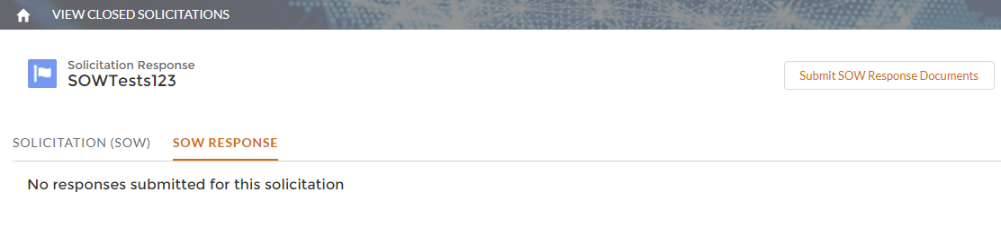

Submit SOW Response
Once you are ready to submit a response, click on the Submit SOW Response Documents.
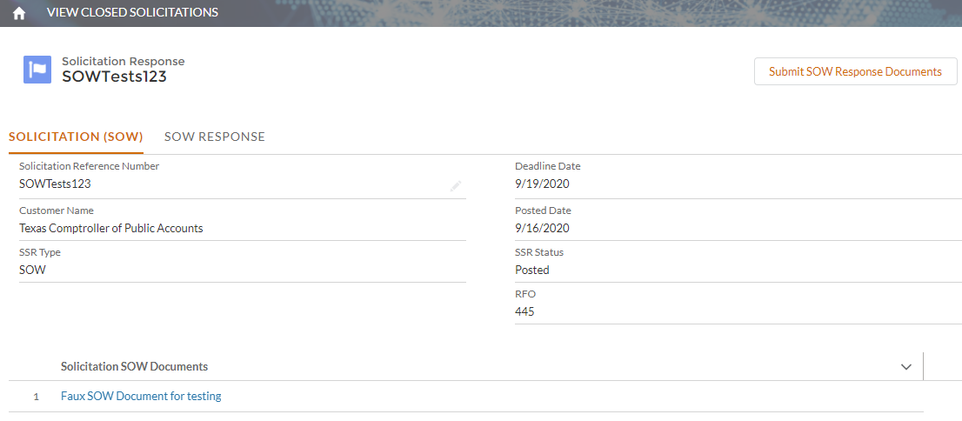
When submitting a SOW Response, note that the only file types allowed are Word, Excel, or PDF. You may upload as many documents as necessary.
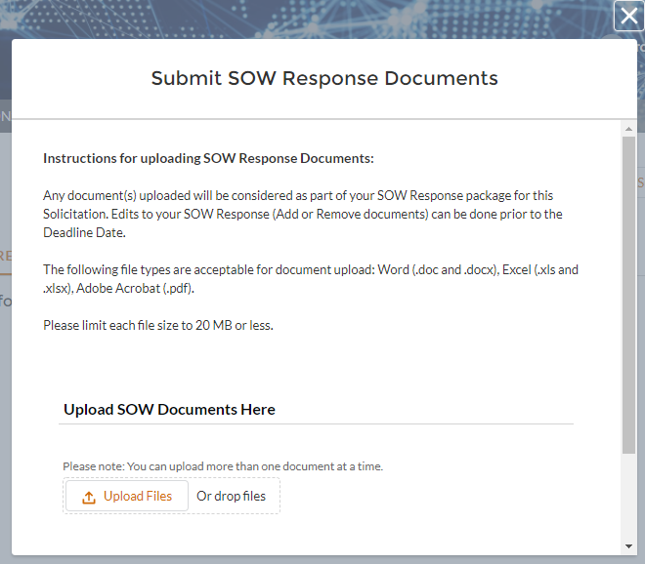
Click the Upload Files link and choose the document(s) you wish to associate with your response.
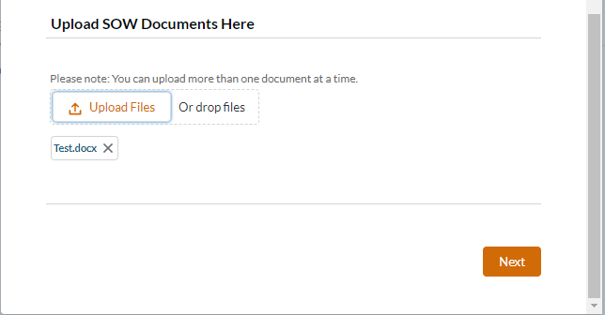
Confirmation screen
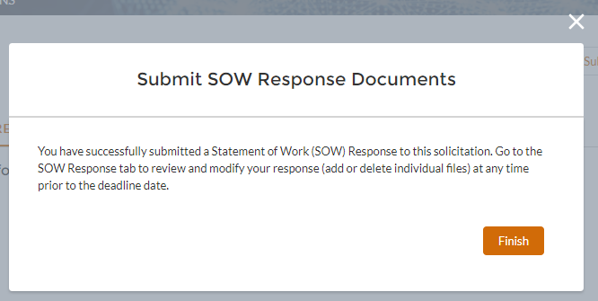

Review and Modify SOW Response
Click on the SOW Response tab to review any existing SOW Response.
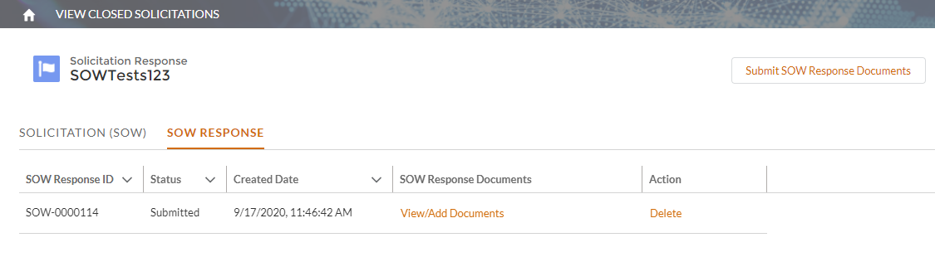
To remove your SOW Response from consideration, click the Delete button in the Action column.
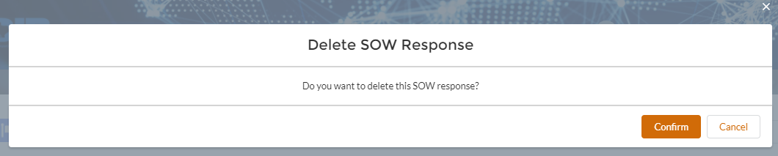
To make edits to your response (Add/Delete documents), click the View/Add Documents link.
Note – At least 1 file must be associated with a response.
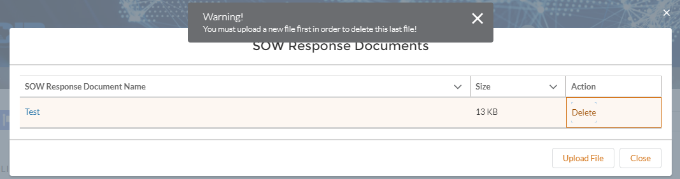

Version History
Version Number | Release Date | Comments
1.0 | 2/24/2020 | Initial Release
2.0 | 3/16/2020 | Updated changes include note regarding multiple accounts per vendor.
3.0 | 10/1/2020 | Updated to reflect changes of Phase 2 enhancements / modifications

